Massachusetts Institute of Technology
Koch Institute for Integrative Cancer Research
Histology Lab
500 Main St. Bldg. 76-182
Cambridge, Ma 02139

Starting up the Sakura Stainer/Coverslipper Units for Use

Principle: Use of the Sakura slide stainer and coverslipper are permitted after hours and on the weekends. Typically during standard working hours, the stainer and coverslipper are ready for use and no work is required to use. After hours and on the weekend, the units need to be turned on, the evaporation covers need to be removed and the units primed. The units can be used to deparaffinze, counterstain, dehydrate and H and E stain slides sectioned from paraffin and frozen blocks. Please ensure that you sign in to use the units, since this is how we show NCI that we’ve trained researchers!

Safety: Gloves and safety glasses are required if reagents need to be added.

Procedure:

- The units must be turned on in the correct sequence.

  - The coverslipper needs to be turned on first. Use the button on the upper right hand side of the unit. (Pink arrow)

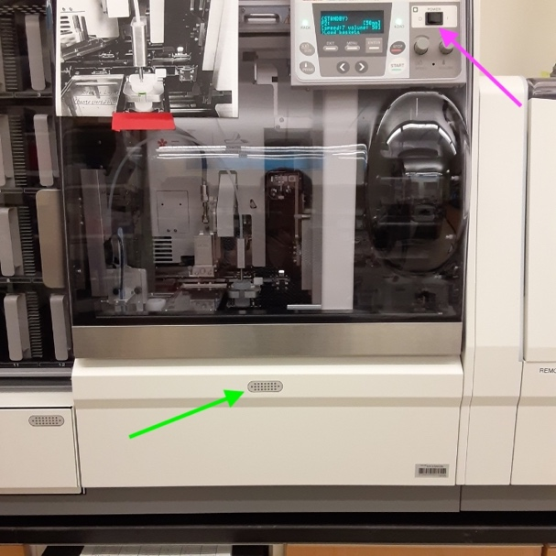

  - Open the clear lid, to the right. Remove any empty slide racks from the carousel. (red arrow)

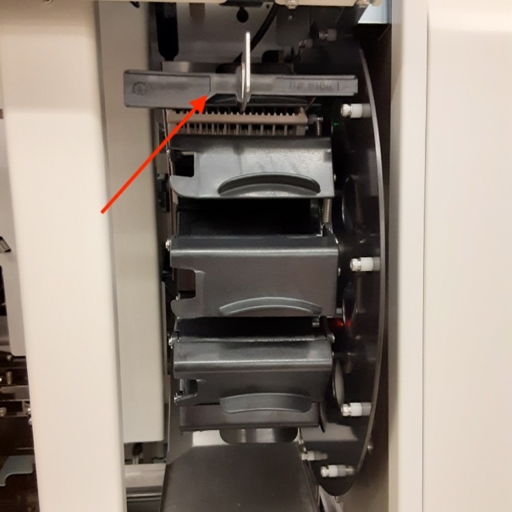

  - Check the coverslip level, add as needed. (coverslips are in drawer below unit)

  - Check the xylene level in this xylene container. Ensure the level is to where the line is.

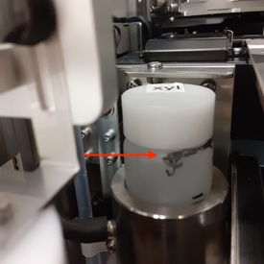

  - Check the xylene level in the needle bath. Ensure the level is to where the line is. Use xylene bottle under the hood (red arrow) as needed to refill the xylene back up to the line.
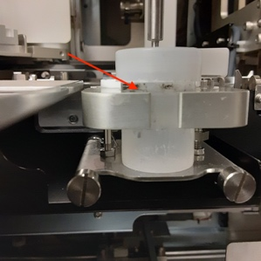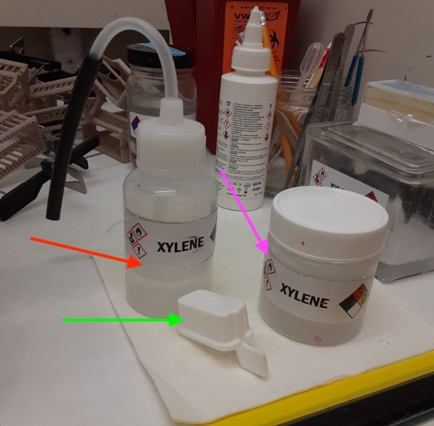

  - Remove the cover from the xylene bath, by opening the door at the bottom of the unit. (green arrow) The cover goes into the drawer right under the unit. Close the door.

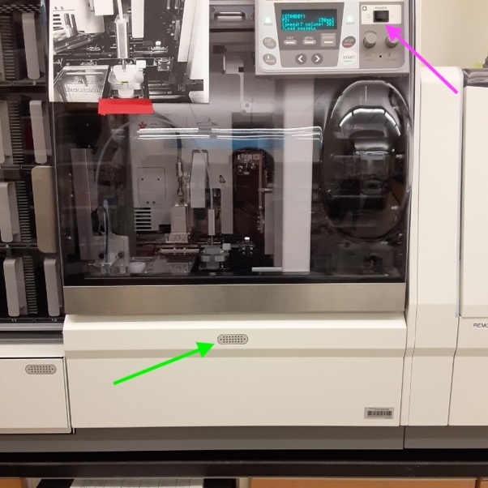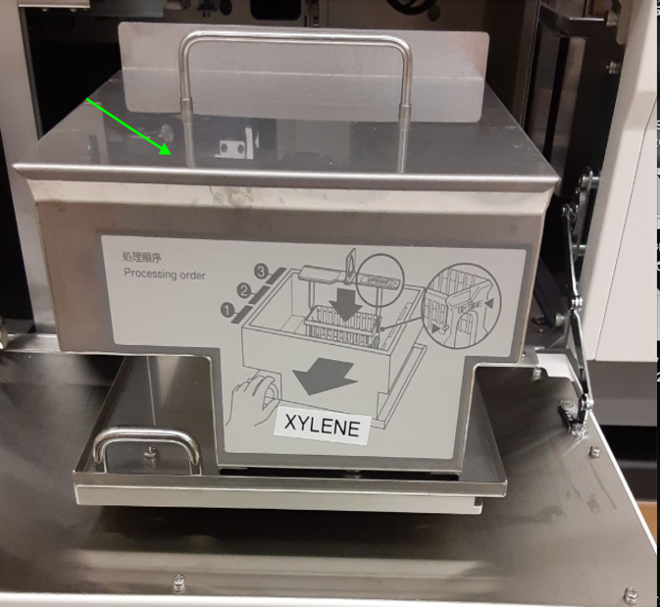

  - Press the “initialize button” to initialize the unit for use. (on the control panel)

  - Remove the glue catcher, by lifting and pushing to the left, (red and blue arrow, it’s on a spring) place in the xylene container under the hood to the right. (pink arrow) Remove the one already in the container, place under the hood to dry. Take the dry one and replace into the unit.

  - 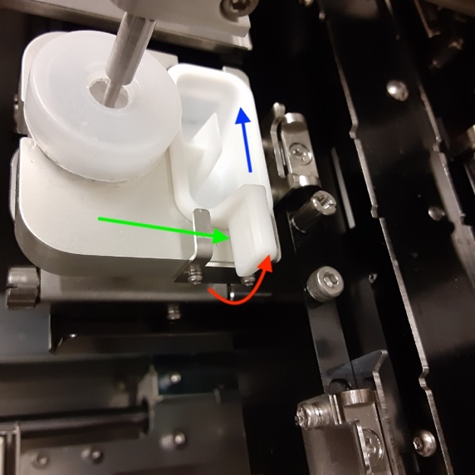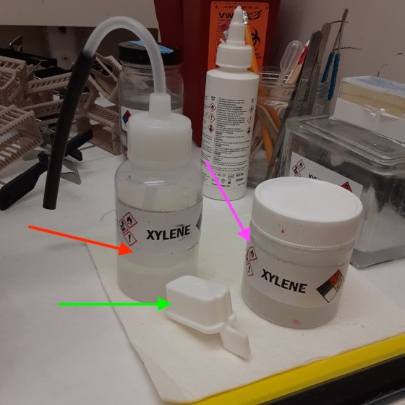

  - Press the prime button to prime the unit x 2.
  - Unit is now ready to use.

- Turn on the stainer using the button on the lower right of the unit. (green arrow)

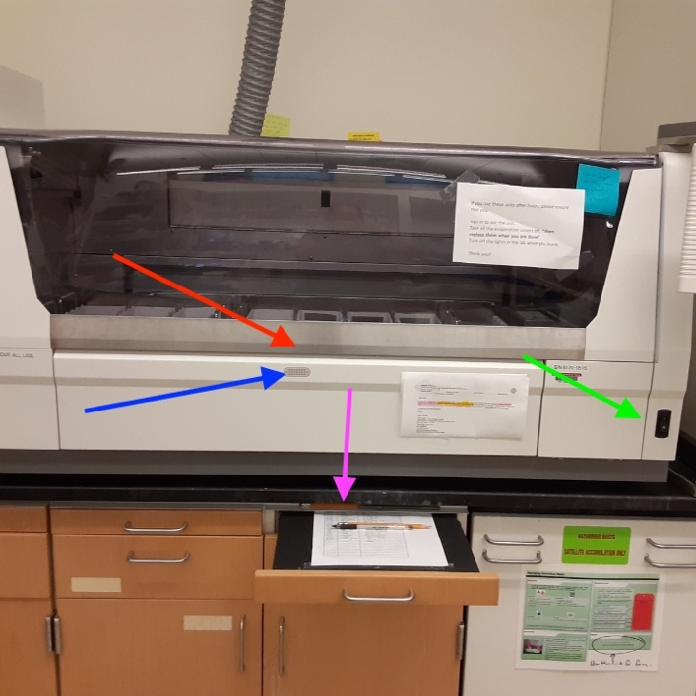

  - Allow the unit to do its initialization procedure. It takes about 1 minute.

  - After the unit initializes, remove the evaporation covers from all the staining jars..

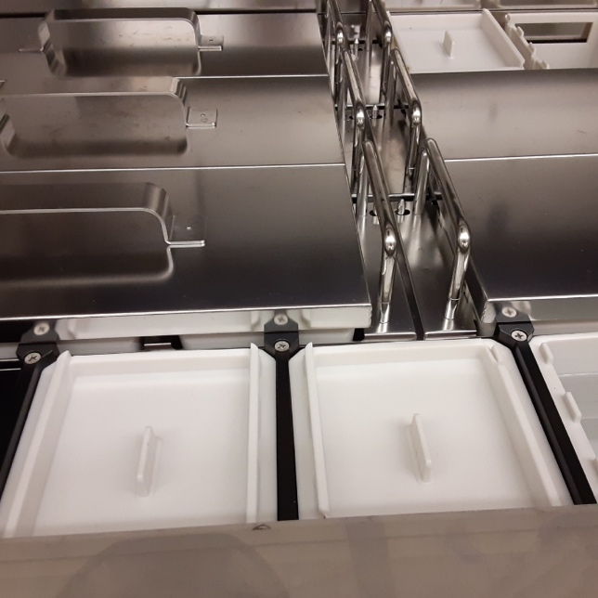

There are 6 metal lids and several white plastic lids. Check carefully that all covers are removed. They are placed into the drawers under the unit.

  - Check the level of the reagents. The reagents need to be filled between the upper and lower lines that are in the reagent jars. Top off as needed. Ethanol and xylene are under the hood to the right of the unit, in the flammable storage cabinet.

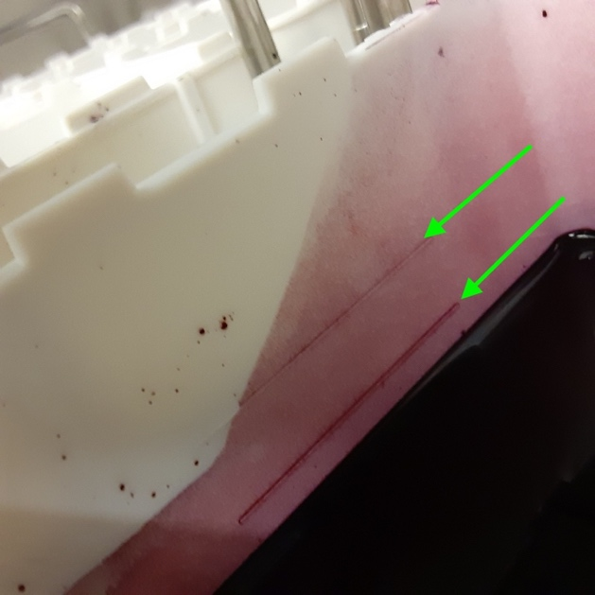

  - The password to get past the main screen is on the back of the movable control screen.

  - Press the “start” button. The unit will ask you to flush the water stations, press yes. Confirm the water is flowing into the back right 3 reagent buckets. Allow the unit to flush the water buckets for about 15 seconds then press the confirm button. You are now ready to stain slides.

  - Look carefully at the slide racks, you will see “upside” on one side of the racks and rack hangers. (red arrow) Ensure your slides are facing the “upside” when you put them into the slide racks. You will note that one side of the slide rack is thicker than the other side. The narrow side should be facing to the right, or “upside”. Also, this unit is all about balance, please load your slides so that they are evenly balanced in the rack and on the arm of the stainer.. If you have one rack place it dead center in the S1 bucket. If you have 2 racks, place them in the left and right slots.

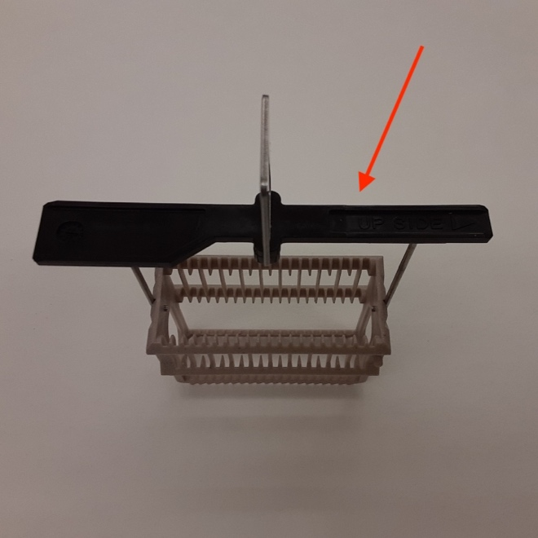

  - On the screen to the left is a list of programs to choose from. Use the slider bar to see the full menu. Select the program you’d like. The next screen that comes up is the screen that asks you how many slides you are loading onto the unit. Enter in the total number and press enter. The S1 bucket will be highlighted. Open the door at the bottom of the unit (blue arrow) and load your slides into the S1 bucket. You can load up to 3 racks of 20 slides each into the S1 loading station/bucket. Close the door.

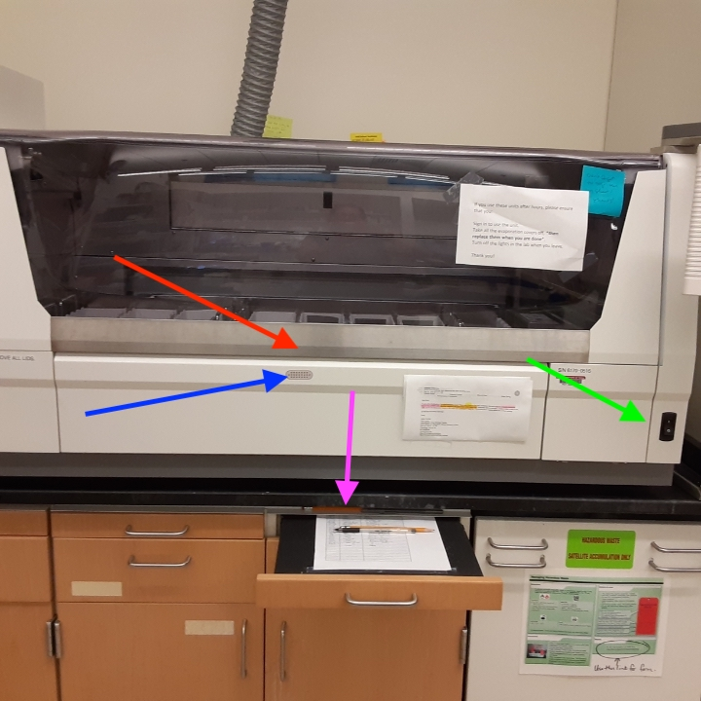

  - The “start” button is now activated on the screen. You can load multiple racks of slides onto the unit, even when other racks are staining.

  - If you chose “deparaffinize” to deparaffinize your slides, they will end in the water station at the front left of the unit. When they are ready, the unit will signal that they are done. Open the unit, take the slides out, confirm on the screen that you’ve taken them out.

  - If you chose any other programs the slides will finish staining and be moved directly to the coverslipper. After they are done being coverslipped, allow them to dry for 30 minutes before placing in a slide box or at least a week for long term storage in a slide storage unit.

- When done using the unit, confirm all slides/racks have been removed from the units. Replace the evaporation covers on both units. Turn off the stainer first (unit to the right) then the coverslipper (unit to the left)

7-15-22/KC

