Massachusetts Institute of Technology
Koch Institute for Integrative Cancer Research
Tang Histology Lab
500 Main St 76-182
Cambridge, Ma 02139

Types of Tissue Cassettes and How to Use Them

There are multiple styles and colors of cassettes. Many places will color code their projects or specimens, hence the different colors. The main types of cassettes are:

Standard:
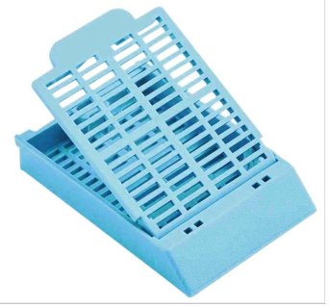
Note that teflon biopsy bags can be used in standard cassettes to hold very small tissue to prevent it from falling out of the cassette during processing. It can also hold floppy membranes well, and prevent them from fragmenting. Insert tissue into the bottom ½ of the bag, fold in half and place into the tissue cassette.
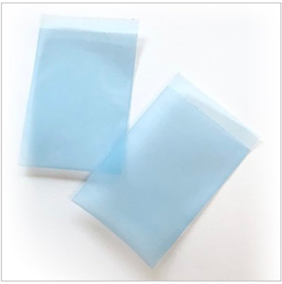

Biopsy:

Note smaller openings so tissue won’t fall out during processing.
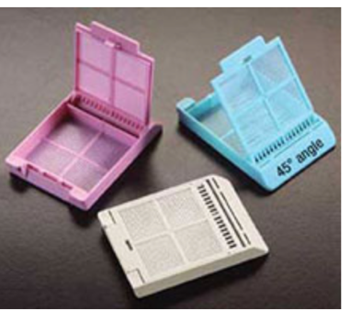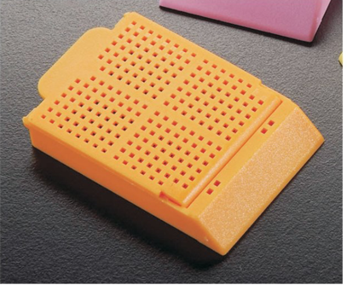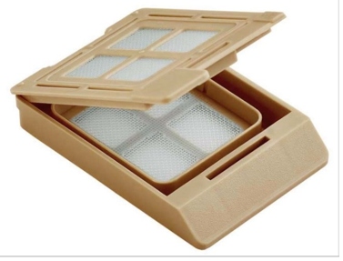

Multi-well cassettes:

The chambers are numbered so that you can ID your tissue.
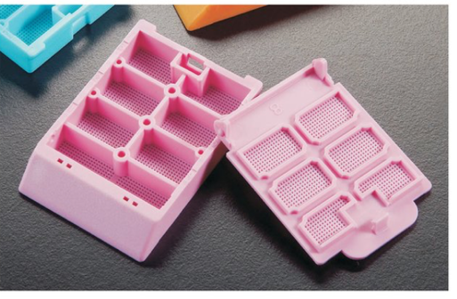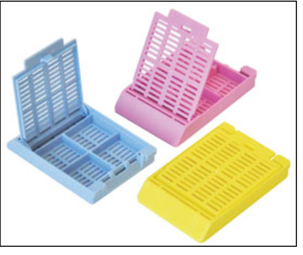

Macro or “double deep” cassettes:
To be used for items that are very large, think tissue with a drug delivery device that you don’t want to shift during processing that has minimal tissue. Cross section of abdominal cavity with injected material or nanoparticles.

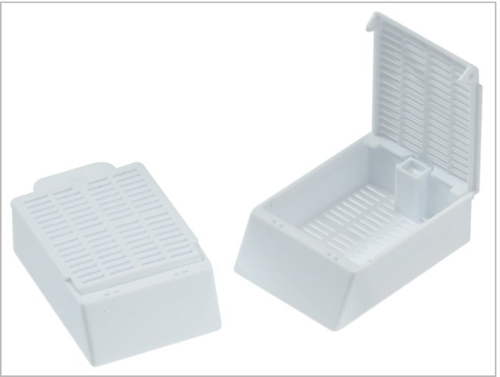

Other items:

Biopsy sponges

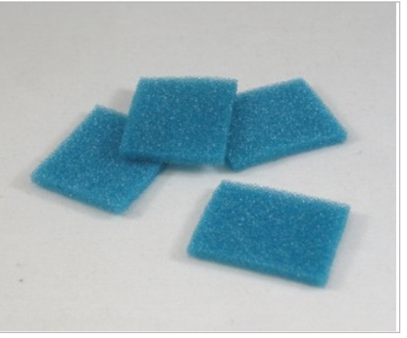

Used to sandwich tissue between 2 sponges which are then inserted into a standard cassette. Used to hold tissue such as skin or resection portions of bowel/tumor flat as they tend to curl up when the tissue is fixing and processing.
To use: soak the sponges in your fixative of choice, just like a kitchen sponge. Sandwich your colon/colon tumor between 2 sponges in the tissue cassette. Place in cassette, close cassette lid.

If you don’t use them, this is what your colon/tumor will look like after processing. All curled up and very difficult to orient to get a clean view of the tumor/colon wall/attachment to the colon.

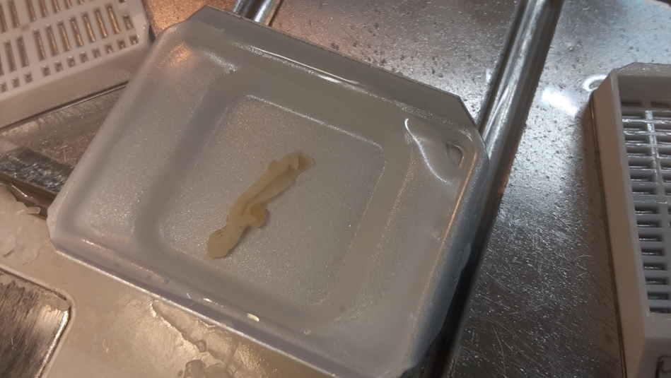

2022-03-30/KC

