Massachusetts Institute of Technology
Koch Institute for Integrative Cancer Research Tang Histology Lab
500 Main St 76-182
Cambridge, Ma 02139

Suggested Sectioning for Tissues for Submission to the Koch Histology Lab

Procedure: The quality of a tissue section depends on every step in grossing, processing, sectioning and staining. Every step is dependent on the step preceding it.

General Considerations:

Grossing: Generally speaking tissues must be “grossed” or trimmed to roughly 4mm in thickness. Tissue that is thicker is usually too thick for the processing reagents to penetrate the tissue resulting in “mushy” tissue, which is extremely difficult to correct and work with. Too thin can also be an issue, as during processing and embedding the tissue becomes very fragile and can easily fracture.

Fixation: Tissue must be adequately fixed. A 4 mm square tissue requires roughly 24 hours of fixation in formalin to be adequately fixed. Smaller pieces of tissue require less time to fix. Fixation should be performed as soon as possible after harvest, as delays permit autolysis and drying. Freezing tissue prior to fixation can cause major morphological changes. 10% neutral buffered formalin is considered the best general fixative, but there are many others that can be used. Please remember that when using formalin or other fixative, a hood certified for use of toxic materials needs to be used as well as standard lab PPE’s (i.e. gloves, safety glasses and lab jacket). If future IHC staining is a possibility, long term storage in formalin is not suggested.

Bones: Any bones must be submitted separately and clearly labeled as bone, so that it can be decalcified prior to processing. If bone is not clearly labeled, it may be processed inadvertently as regular tissue, with no decal. This would render it almost impossible to section and place on to a slide.

Labeling of cassettes: Cassettes must be clearly labeled in pencil (no markers) in the standard Koch Histology method (see “Submitting Tissue to the Koch Histology Lab” SOP). Tissues that are too small, may fall out of the cassette during processing, the use of “biopsy bags” or “biopsy cassettes” or even lens paper to contain the tissue is strongly encouraged. (please drop by the histology lab, and we can demonstrate what these are)

Clean up those tissues: The stomach contents (i.e. food material), gastrointestinal contents (i.e. fecal material) and large blood clots must be removed to ensure quality sections on the slides. Food and fecal material act like grit in the paraffin blocks, nick our knives and then shred the tissue during sectioning, greatly reducing the quality of the final product.

General Guidelines for Trimming of Mouse Tissue: Ask yourself; do you really need all that tissue that you have crammed into the cassette (i.e. all the liver lobes submitted in one cassette?) Like tissue should be submitted with like tissue. I.e. liver, kidney and spleen can be submitted together. Brain should be submitted separately. Heart and muscle together. Rat tissue may be trimmed similarly, but since the tissue is larger, more cassettes will be needed.

Brain: One cross section (i.e. transverse section) through cerebrum and one through cerebellum.

Heart: Bisect the heart longitudinally (sagittal) slightly asymmetrically to display all 4 chambers.

Lungs: All lobes may be submitted attached to the trachea/esophagus.

Liver: One cross section through the area of interest (i.e. tumor).

Kidneys: One longitudinal (sagittal) through the left kidney and one cross section (transverse) through the right kidney.

Adrenals: Submitted whole, if left and right need to be delineated, use grossing ink to mark one adrenal.

Spleen: One cross (transverse) section of spleen.

Stomach: Trim a strip of glandular and non-glandular stomach wall.

Gastrointestinal tissue: One short (3 mm) segment from all 6 portions of G.I. (stomach, duodenum, jejunum, ileum, cecum and colon). If the entire GI (not including stomach) is needed, open the GI along it’s entire length, remove fecal contents, fix well, roll into a “jelly roll” and submit the entire length in a cassette.

Biopsy sponges:
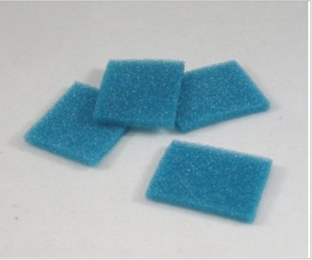

Used to sandwich tissue between 2 sponges which are then inserted into a standard cassette. Used to hold tissue such as skin or resection portions of bowel/tumor flat as they tend to curl up when the tissue is fixing and processing.

To use: soak the sponges in your fixative of choice, just like a kitchen sponge. Sandwich your colon/colon tumor between 2 sponges in the tissue cassette. Place in cassette, close cassette lid.

If you don’t use them, this is what your colon/tumor will look like after processing. All curled up and very difficult to orient to get a clean view of the tumor/colon wall/attachment to the colon. ®
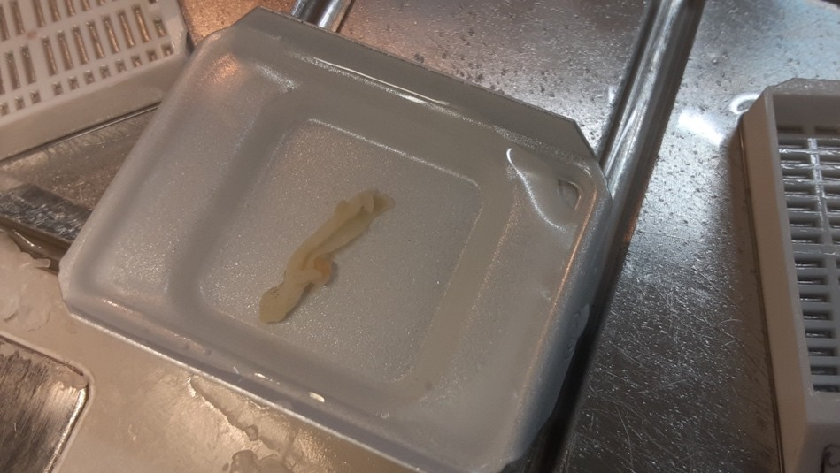

Skin: A strip from area of interest (i.e. injection site)

Bladder: Open bladder to allow regents to penetrate, submit whole.

Eyes: If possible, keep optic nerve attached, submit whole.

Reproductive tissue: Uterus can be submitted whole if small enough, but segments from left and right horn and cervix can be submitted. Ovaries can be submitted attached to the horns or separately if needed. Testicles, left should be longitudinally (sagitally) sectioned, and right cross (transversely) sectioned.

There are many variations on a theme, we would be happy to chat about what your needs are and we would be pleased to discuss any other tissues/constructs etc that you may wish to submit.

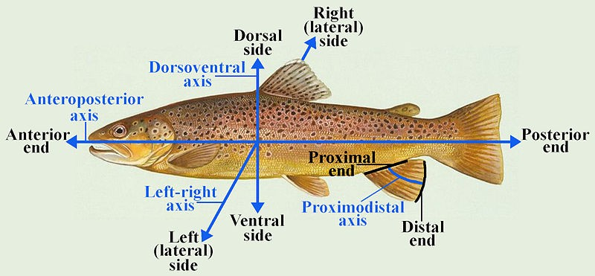

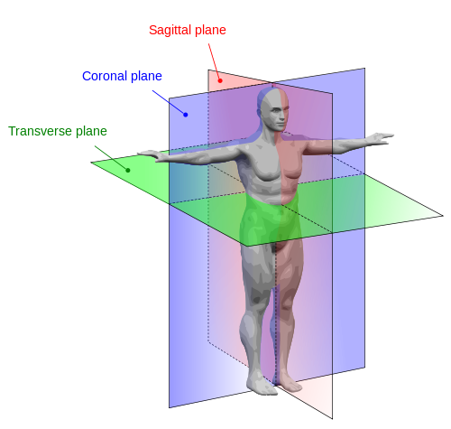

2022-03-30/KC

