Massachusetts Institute of Technology
Koch Institute for Integrative Cancer Research
Tang Histology Lab
500 Main St Bldg. 76-182
Cambridge, Ma 02139

Suggested Guidelines for Processing Tissues to Freezing for Future Cryosections

Materials needed:
dry ice
liquid nitrogen
deep tray to place the dry ice in
steel bowl to place into the dry ice and to fill with liquid nitrogen
tissue to be snap frozen
peel away molds (available in histology)
OCT or other commercially available freezing compound (available in histology)
long forceps to place the molds into the liquid nitrogen
Insulated gloves for handling the dry ice/liquid nitrogen

Solutions needed: (if doing sucrose infiltration)

15% sucrose 15 gms sucrose
100 mls distilled water

30% sucrose 30 gms sucrose
100 mls distilled water

Safety: Safety glasses, insulated gloves (for the dry ice and liquid nitrogen) nitrile gloves and lab jacket.

Principle: Cryopreserved tissue can be used for crysections or other uses (i.e. flow cytometry). There are many methods but the below describe the methods that we recommend. Sucrose infiltration of the tissue is not always needed but is included for those who wish to use it.

Procedure:

- Prepare the liquid nitrogen/basin and dry ice. Place the dry ice into the deep tray, then place the steel basin into the center of the dry ice. Surround the basin with dry ice. Carefully pour liquid nitrogen into the steel basin. Pour enough liquid nitrogen to surround the future embedding molds, but not enough to submerge the molds.

- Harvest the tissue of interest. Trim any excess fat, remove any blood clots, and blot the tissue dry with a paper towel.

- Take the labeled freeze mold, and place the tissue into the bottom center of the mold. If there are several pieces of tissue, place them all into the center of the mold. The bottom of the mold is where we start sectioning the tissue. 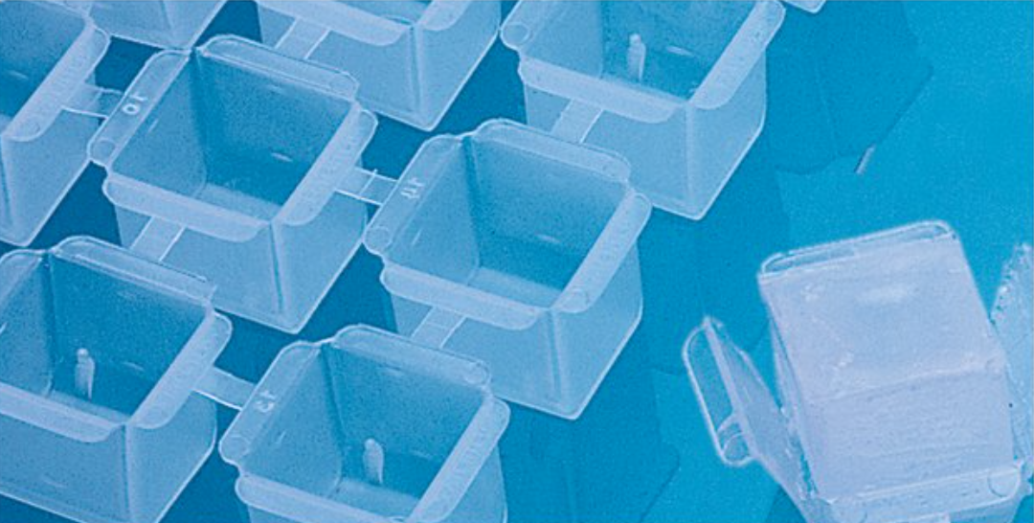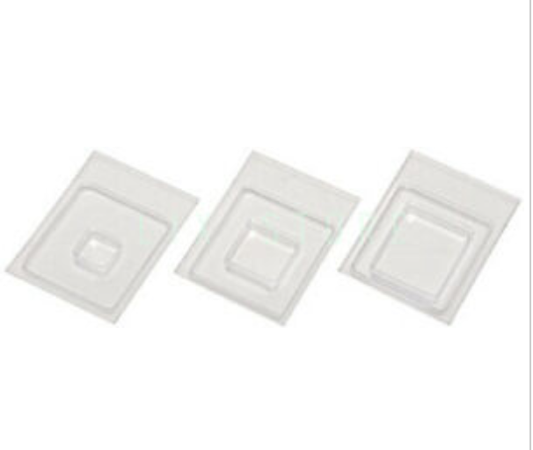

- Surround the tissue with OCT and let to sit for 2-5 minutes to allow the air bubbles to rise to the top of the mold and to allow the freeze media to fully ooze into the grooves/valley of the tissues. Do not fill the embedding mold more than ¾ full, otherwise it is very difficult to remove the block from the mold.

- When you have several blocks ready, place them all into the liquid nitrogen/basin to freeze. The blocks will be ready in around 10 seconds or less, or when the top of the block starts to get grey/looks thickened. Store at -80°C for up to one year.

Lungs for frozen sectioning

- Mouse tissue: Make a tiny V shaped cut at the top of the trachea, then introduce a dulled small gauge needle (i.e. 19 gauge) with syringe containing roughly 2.5 ml of OCT. Slowly inject the lung with the OCT and watch the lungs inflate. Avoid over inflation of the lung, as this blows alveoli away. The OCT is not diluted. However, if the lungs are from very young mice, diluting the OCT w/ saline might be needed. (the dilution can go up to 50/50 OCT/saline)

- Clamp the trachea off with hemostats and dissect the lung out, lifting carefully by the trachea. Remove the heart (and needle) and snap freeze in the embedding mold, using the above method. Store at -80°C. We recommend that one lobe (usually the left as it is the largest) is chosen to be embedded in the mold.

Sucrose infiltrating/processing of tissue

- After the tissue has been fixed in the preferred fixative, place the tissue that has been trimmed of excess fat and blood clots into a labeled standard tissue processing cassette. Place into the 15% sucrose solution for 2-4 hours at 4° C. Take the tissue, and then place into the 30% sucrose overnight at 4°C.

- Take the tissue out of sucrose, blot (really) well with a paper towel. Place the tissue into a petri dish or similar container, surround with OCT. Allow to sit for a minute or two. Repeat several times with fresh OCT. When done, place the samples centrally into a freeze mold, surround with OCT, allow to sit for 2-5 minutes to let the air bubbles to rise and the freeze media to get into the grooves of the tissue.

- Place centrally into the peel away embedding mold, surround with OCT. Snap freeze in the above described manner. Store at -80°C for up to one year.

2022-03-30/KC

References:

K Misra; T V. Taksir; J Johnson; S Ryan Cryopreservation Method Optimization for Mouse Brain Tissue. Histologic Technical Bulletin for Histotechnology June 2011.

S Steu; M Baucamp; G von Dach; M Bawohl;S Dettwiler; M Storz; H Moch; P Schraml A Procedure for Tissue Freezing and Processing Applicable to both Intra-operative Frozen Section Diagnosis and Tissue Banking in Surgical Pathology. Virchow Arch (2008) 452:305-312

Histonet Archives: Gayle Callis 2/3/2006 Paraffin Embedding of Frozen Tissue.

