Leica Aperio Slide Scanner Start-up Guide

Please note - your images will be stored under the Histology Rowely folder, by PI, researcher name, date scanned. If you exceed your allotted 1 terabyte of data storage, your PI will be billed accordingly by the Bioinformatics staff at the current rate. These Eiles are large, so realize you may get to 1 terabyte more quickly than you think. The Eiles will remain in the Rowley/Histology subfolder for up to 3 years and can be added to eSlide Manager database if you wish to use this to organize your images and access the built-in Image Analysis algorithms for quantiEication. See instructions below.

Viewing your Images:
Your digital slides are saved as .svs Eiles. There are several options available for opening these types of Eiles. (See https://medevel.com/10-os-whole-slide-image/ for a short list.) We recommend the options below.

- ImageScope software is available from Leica, with which you can adjust magniEication, pan and zoom, compare different stains, annotate areas of interest, perform image analysis, and more. This software is compatible with eSlide Manager. You may download the free software here: http://www.leicabiosystems.com/pathology-imaging/aperio-epathology/integrate/ imagescope/

- QuPath is open source software for digital pathology that does everything ImageScope does but works on both Mac and PC! It contains it’s own Image Analysis algorithms and is not compatible with eSlide Manager, however this software is preferred by many researchers. Free download available here: https://qupath.github.io

- WebScope is the default web viewer when opening slides from eSlide Manager on any computer or device with no viewing software installed. However it has limited options for image manipulation compared to the ImageScope or QuPath and it only opens slides from the eSlide Manager database. Please note, WebScope is not supported by the Google Chrome web browser!

- If you really want to use ImageScope on your Mac you can download VMFusion,

which allows you to download a PC desktop onto your Mac. This is free
through IS&T. Just go to YouTube and search for VirtualBox Mac and you will see

videos on how to do this. It’s slow and may crash your computer so it is not our recommended method.

Using eSlide Manager

eSlide Manager is a web-based, searchable data management system that allows you to organize your slides into different projects, make notes, upload documents, store image analysis results, share images, etc… It’s very useful if you do a lot of scanning and quantiEication.

You access the website by going to ki-histology.mit.edu. Note – due to Cirewall restrictions this is only accessible on MIT campus or via VPN!

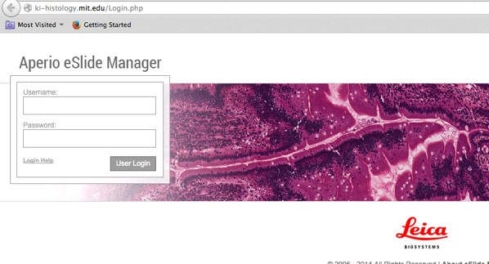The log in page looks like this:

Your login will be your Kerberos name and the default password= slides

The Eirst screen as you log in will be this:

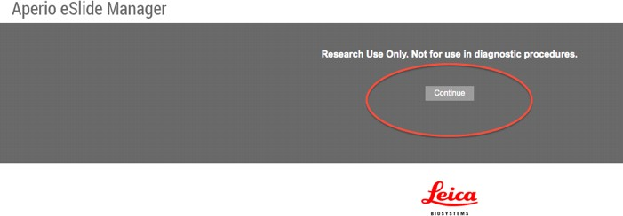
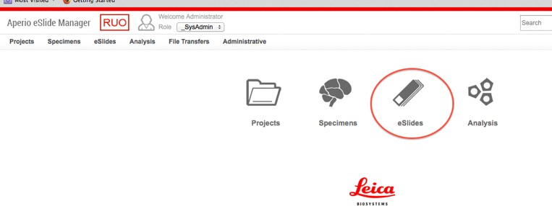Click continue. Next will be:

Click eslides.

To move images into eSlide Manager, do the following:

- Click the eSlides tab, then click Add eSlides.

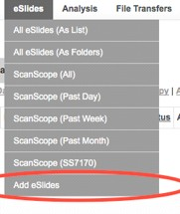

- Click on the browse button to select your images from your dated Histology folder on Rowley. Enter in what Data Group you would like it assigned to. Click add.
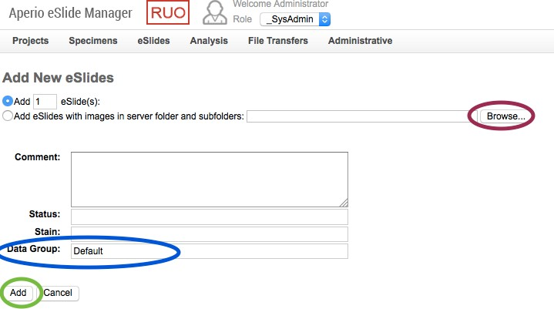

3. Your images are now transferred to eSlide manager. If you inadvertently delete them from eSlide manager, they are permanently gone and will need to be re- scanned (at the regular cost)!

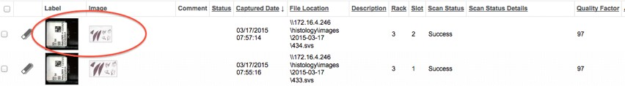

To view images, click any image to open. The scanned image will open in ImageScope or WebScope, depending on what is installed on the computer. You are ready to view/work up your images. You can access your images from any computer.

If you do not wish to use eSlide Manager, you can access your scanned images directly from the Rowley server.

You can load the Rowley/Histology server onto your desktop. smb:// rowley.mit.edu/histology Instructions for that can be here:

http://rous.mit.edu/index.php/Accessing_and_Using_Data_Storage The page will look like this:
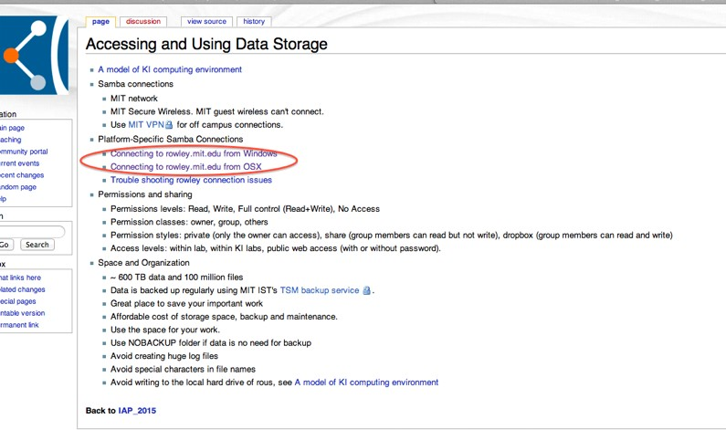

Click on either “Connecting to Rowley from Windows “ or “Connecting to Rowley from OSX”.

Follow the instructions on how to connect. You will need to open the Histology folder in Rowley, which you will have access to. If you do not, please let us know. It should look like this:
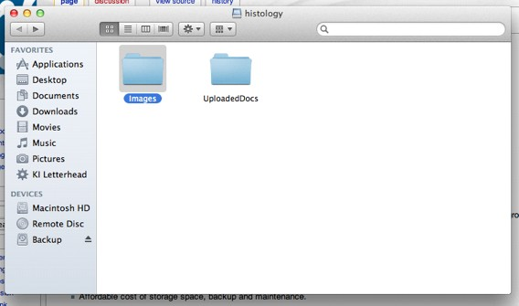

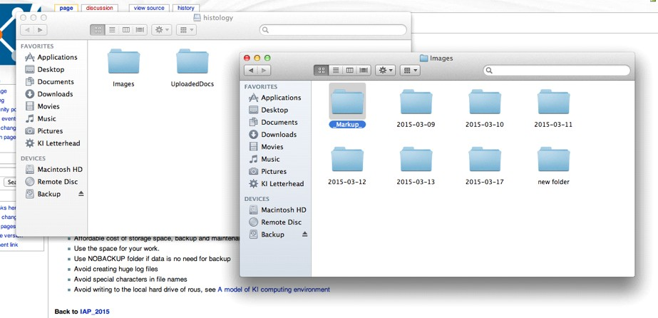

Find the folder with your slides, which is sorted by PI -> Researcher -> date scanned. If you cannot Eind your images in the folder with the date that you think it’s scanned in, check the folder a day before and a day after, we might have shifted the dates scanned to accommodate our workElow.

Finally, if you do not have a Rowley account we can put the Eiles on a public server that you can still access from a computer/laptop/device on Campus. We will leave the Eiles there for a week before deleting them so you should transfer the Eiles to a hard drive or cloud storage of your choice ASAP. To access, connect to an MIT Wi-Fi network (either MIT or MIT Secure) and open Internet browser (Firefox or Safari preferred)

Go to: http://rowley.mit.edu/histology_web/ or http://ki-data.mit.edu/histology

username: histology password: koch76

Alternatively if you provide a hard drive we can copy the Eiles onto the drive from our workstation.

User guides for eSlide Manager, ImageScope and for performing image analysis using ImageScope/WebScope are available on the Histology folder in Rowley at Rowley -> Histology -> Images -> Aperio Guides.

Please let us know if you:
Cannot access your images.
Are missing any images. (They may not have scanned due to some defect of the slide or might not have transferred correctly).
See anyone else’s images.
Have any questions or need advice.

Cac/06-28-2022

