Massachusetts Institute of Technology
Koch Institute for Integrative Cancer Research
Tang Histology Lab
500 Main St 76-182
Cambridge, Ma 02139

Guidelines for Tissue Submission to the Koch Histology Lab
Location: 76-182 Lab hours: 5:00 am to 7:00 pm (hours may shift during higher vacation periods)
Lab phone: 258-8183 for all questions relating to the Histology lab or services

Lab Manager Kathy Cormier cormier@mit.edu
Lab Staff:
Alicia Caron acaron@mit.edu
Charlene Condon ccondon@mit.edu
Weijia Zhang wzhang@mit.edu

Tissue labeling requirements:

- Tissues for processing to paraffin:
  - Tissue must be received in processing cassettes. 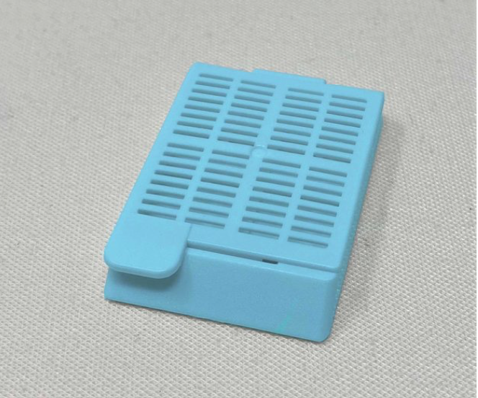
  - The labeling must be in pencil, on the face of the block. Please write clearly and firmly.

- Tissues for processing to frozen sections/slides:
  - Tissue must be received in frozen section embedding mold. 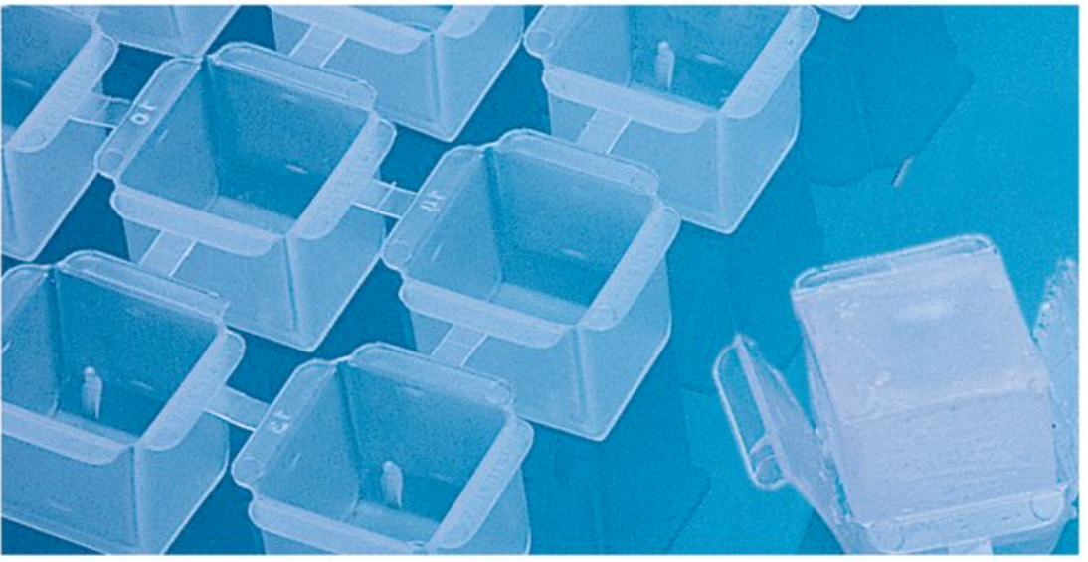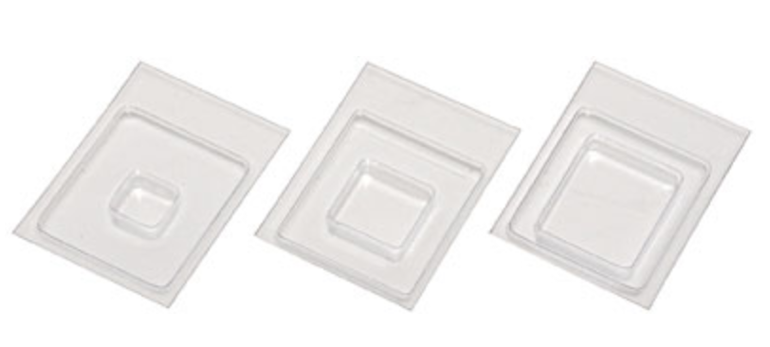
  - The sample must be labeled in solvent/alcohol resistant marker on the side of the mold or the lip of the mold. Tissue must be received frozen. Place the tissue in the bottom of the mold. Surround with freeze media. Allow the tissue and media sit for 2-5 minutes to allow the media to fully ooze into the tissues grooves and outer surfaces. Please fill the embedding mold between 1/3 to 2/3 full of freeze media. The tissue should be fully covered by frozen section embedding compound. Snap freeze the tissue. Please reference the “Suggested Freezing of Tissues for Future Frozen Sectioning”. The lab will notify you when it will be ready to receive the samples. (We have limited storage space in the -20 freezer)

- Labeling:
  - Researchers’ initials, then some very short systematic numbering system to identify your samples.
For example: If someone submitted a processing cassette labeled “KC 68A2”, KC would be the initials of the submitter, 68 would be the animal number, A would be the specimen and 2 would be the second block for that specimen. The slide would look like this “KC 68A2”
In general, it is better to keep the labeling very short as there is very limited space on the face of the block. The minimum labeling required would be initials, and a short number. The longer the label, the longer it takes to type onto the slide, and the longer it takes to get back to you.

- The samples for processing to paraffin must be received in appropriate reagent (i.e., 70% ethanol. No formalin please) in a leakproof container, with the HCF (Histology Core Facility) number (assigned in iLab when you submit your request) and 70% ethanol on the outside of the container. Alternatively, you can put your name and 70% ethanol on the container.

- “Request form” (i.e., service request form, special stain request form) must be submitted with in 24 hours of us receiving the samples, or you can enter in the request in iLab, and then drop off the samples within 24 hours of submitting the request.

- Pricing is available at https://ki-sbc.mit.edu/histology/pricing

Tissue Guidelines:

- For optimal fixative penetration, tissues should be no thicker than 4 mm, for any fixative.

- For optimal tissue fixation, fix tissues for 20-24 hours, if tissue is fixed in formalin. Fix slightly longer for fatty tissues or for fixatives other than formalin. Biopsy tissue or embryos less than 12.5 days can be fixed for a shorter period, such as 5-8 hours. (Biopsy meaning tissue no larger than 1x 1 x 0.5 mm.)

- Tissue not adequately fixed cannot be remedied.

- Tissue that will be used for future immunohistochemical staining should not be fixed in formalin longer than 24 hours. Smaller samples can be fixed for shorter periods. After 20-24 hours fixation in formalin, tissue should be transferred to 70% ethanol for long term storage until it is submitted to the Histology lab for processing.

- For small biopsies, a biopsy cassette, tissue sponges or lens paper may be needed to ensure that the biopsy is not lost during processing. Please drop by to see what these items are.

- The standard histologic stain for most tissues is hematoxylin and eosin (H&E).

- We also can provide unstained sections and the following special stains:

Special stains:

Carbohydrate stains

PAS 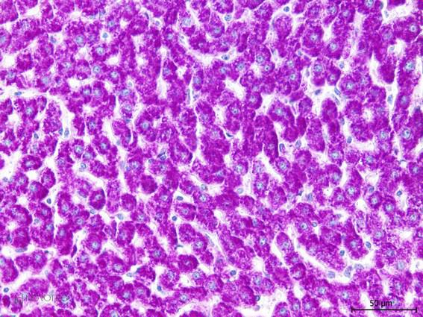 PAS (+diastase digestion) 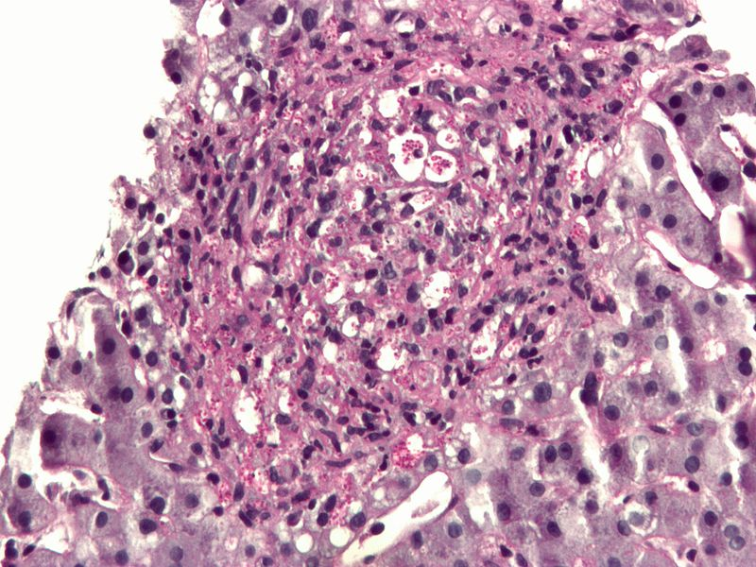 Alcian blue 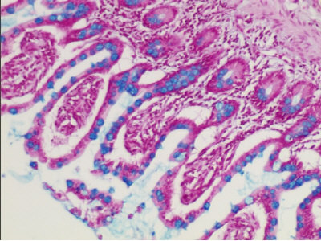

Hematological stains

Wright Giemsa Toluidine blue

Connective tissue stains

Trichrome 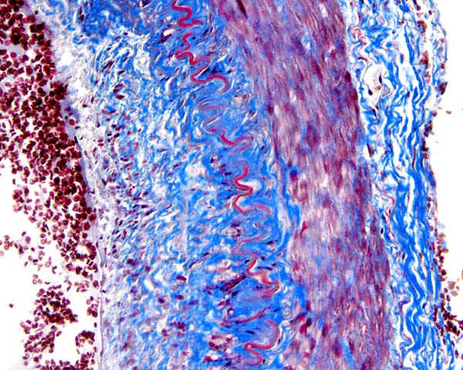 Verhoeff-Van Gieson

Oil Red O (frozen sections only) 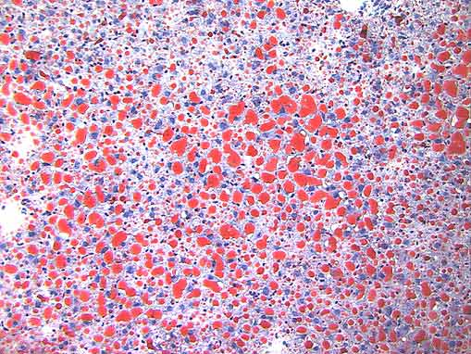

Nerve stains

Luxol Fast blue 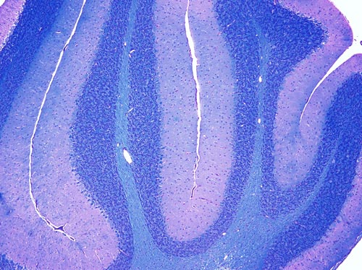 Cresyl Echt Violet 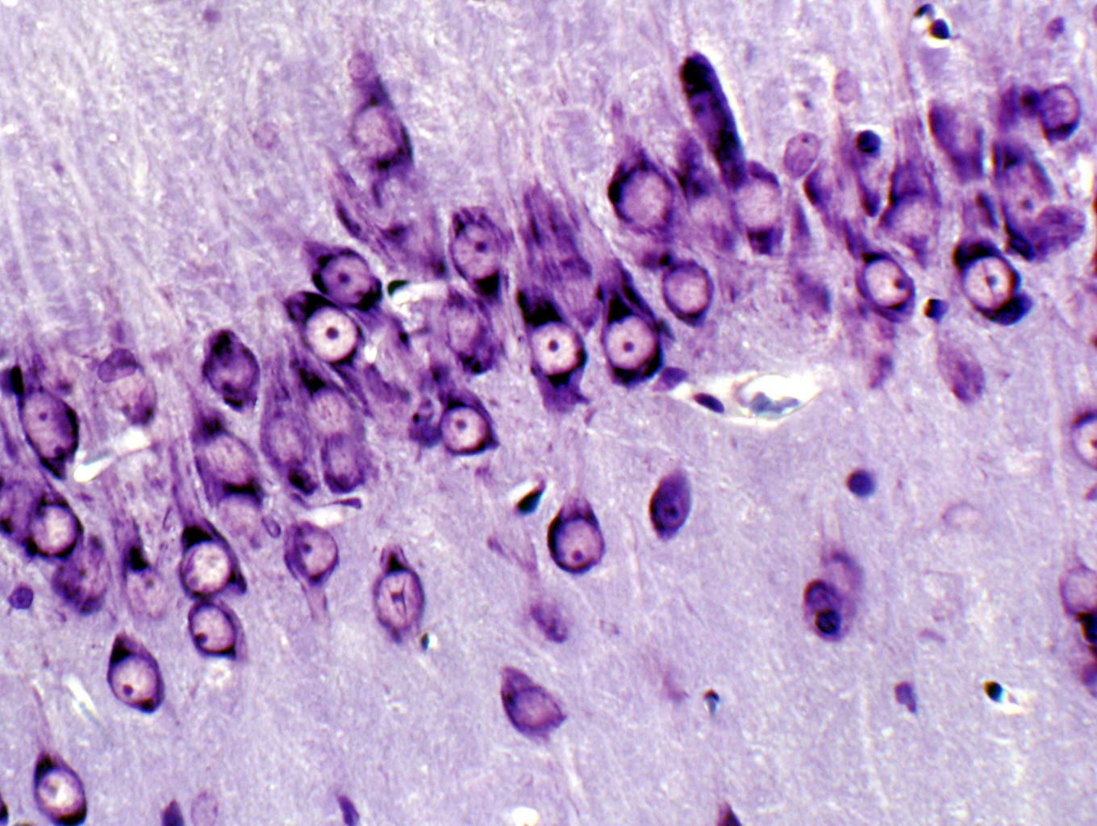

Immunohistochemistry (IHC) (mostly for mouse primary antibody on mouse tissues):

The KI standard automated IHC (ThermoScientific IHC Autostainer 360) run consists of:

Endogenous peroxidase blocking: 10 minutes
Protein block: 30 minutes
Primary antibody: 60 minutes
Labeled polymer: 15 minutes
DAB: 5 minutes

Other programs are available for other species/primaries, please contact the Histology lab to discuss options.

Example of positive nuclear IHC staining: 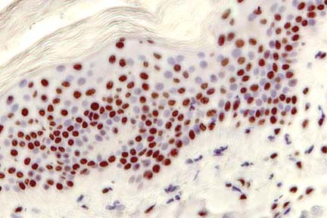

Example of positive cytoplasmic IHC staining: 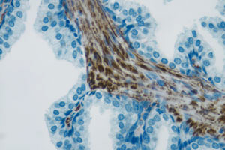

Example of positive membranous IHC staining: 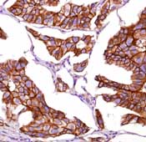

2022-03-30/KC

