Filling Out the iLab Forms
(Or what does “step section” really mean?)

Please keep in mind that if you requested something such as step sections at 50 um, with H and E’s on slides 1, 3, 5 unstained slides on 2, 4, and 6, on your previous submission, you will need to enter that on each requisition, each time, if that is what you would like. We will not assume that is what you require on each submission.

Your choices:

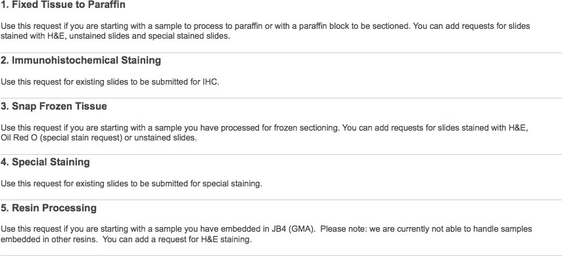

Choosing this option allows you to submit wet cassetted tissue to be processed to paraffin blocks/sectioning, or to submit paraffin blocks to be sectioned.

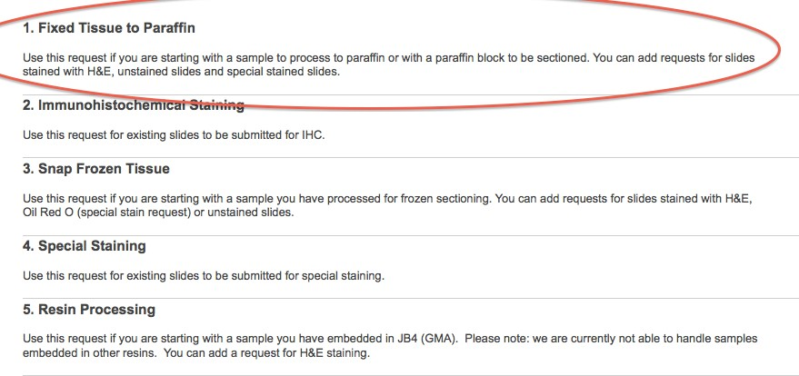

This area of the form allows free text. It is used to let us know what you’re giving us to work with. It might be cell pellets in histogel/argarose or bone with implant or just paraffin blocks for further sectioning. Feel free to add any clarifying information in this area.

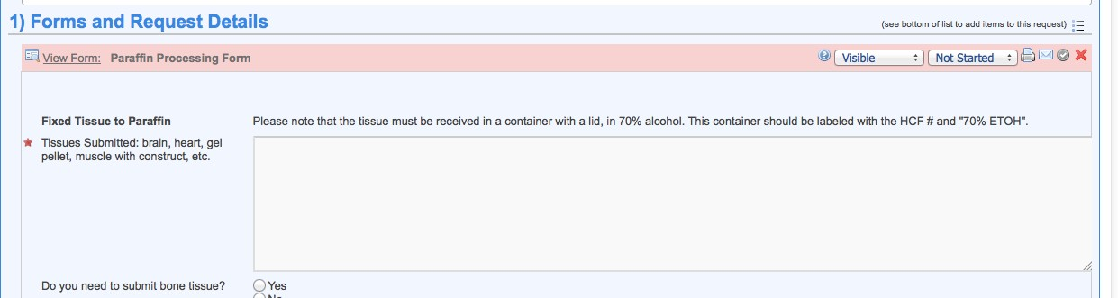

This area of the form lets you tell us if you’re submitting bone and what fixative you used. Please ensure that when you submit bone, the bone cassettes are in a separate container labeled “BONE”, so that we can decalcify them. Some bone, if fixed in Bouins may not need further decalcification in the Histology core. If your bone tissue has been determined to not need further decalcification, you need to enter that onto the iLab form, each time you submit bone. If you do not enter this information, we will assume your bone needs decalcification, and will decalcify it.
This may damage your tissue.
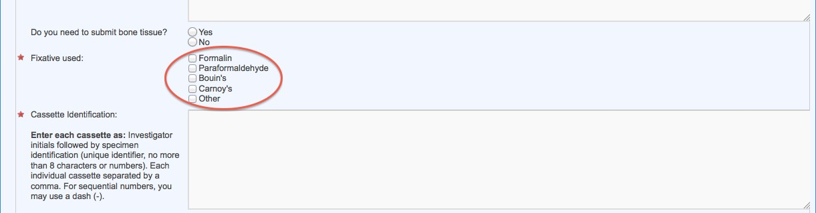

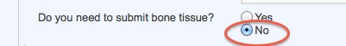

This part of the form is where you enter in your cassette information (i.e. your initials that are on the cassette followed by a short numerical designation). Pencil should be used to mark cassettes. 99% of markers will dissolve off the cassettes during processing in our tissue processor. Please don’t risk your valuable samples, use pencil.
This area of the form is free text. Feel free to add in any clarifying information you feel is needed. (i.e. 3 step sections at 50 um, slides 1,3,5 for H and E, slides 2,4,6 for trichrome, looking for implanted materials). Serial numbers can be designated using a dash, i.e. 1-25.

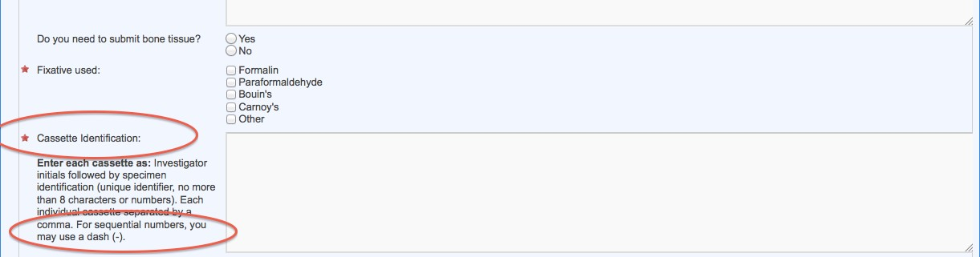

Please be accurate in filling out the total number of cassettes that are submitted. If there is a discrepancy in numbers (total numbers, smudged numbers, numbering not matching what is listed on the requisition), it requires some emails back and forth, which delays processing your tissue, which means that your samples get back to you slower. Embedding instructions are critical to us, they let us know what you’re looking for. Please feel free to use the free text areas to clarify your needs or to drop by and let us know what you would like us to do.

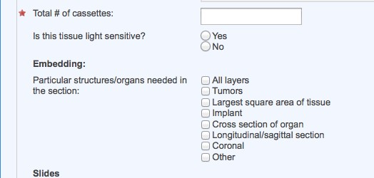

The standard thickness for sections that we section at is 4 or 5 um for paraffin. If you need thicker sections, we can do this. Please let us know what thickness you need and why, i.e. 8um for ISH etc.
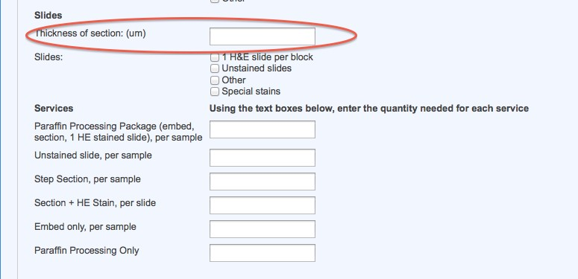

This area of the form is for letting us know what you want, per block.

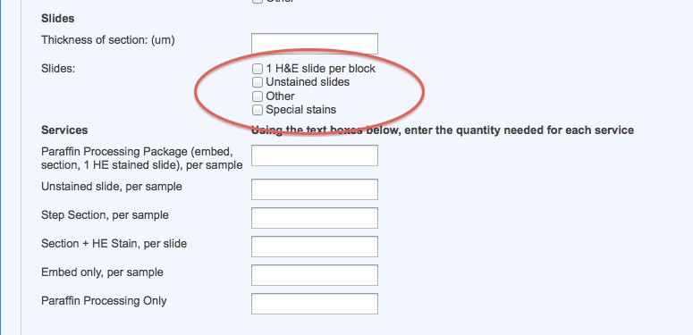

The area of the form, circled in red, is the most common request. Please note that this is per sample. You will get one paraffin block back with one H and E slide.

The area of the form, circled in green, is for unstained slides, per sample. I.e. if you enter in 3 here, you will get 3 unstained slides per paraffin block.

The area of the form, circled in purple, is for step sections. Step sections are specified “steps” or depths that we will section into the paraffin blocks for you, so that you can get a slide that is deeper into the block. This is usually done so that one can see fibrosis/tumors/implants/damage at different areas (depths) in the paraffin block/tissue. There is a nominal charge for each step. (plus the cost of whatever is requested at that step, such as an H and E stained slide or unstained slides).

The area of the form, circled in yellow, is for additional H and E sections, from paraffin blocks, or for additional H and E sections from wet tissue that is being submitted.

The area of the form, circled in black is for wet tissue that is being submitted for processing to paraffin only (you do the embedding) or for wet tissue that is being submitted to be processed to paraffin and embedded by us. Then you would pick up the paraffin blocks to be sectioned by you or someone else.

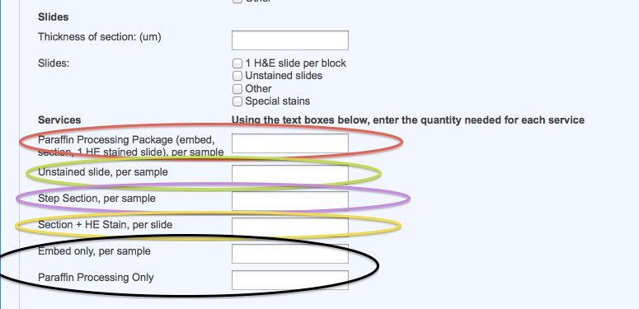

This area of the form allows you to enter in if you have special stains that you would like in addition to your H and E’s. If you click yes, the special stain form will open, and you fill out what you would like. You are required to fill this portion of the form, if you do not the form will not allow you to save it.
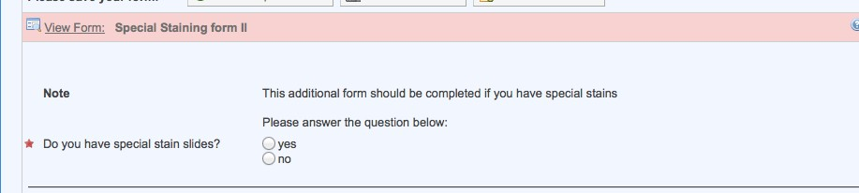

After the Histology Core adds the charges associated with your requisition, you are required to click the “agree” button in iLab. You will get an automated email from iLab when the charges are added.
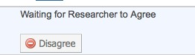

This shows that the charges have been agreed to, and the case is ready to start processing.
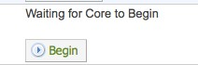

This shows that the case has started to be sectioned.
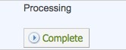

You will get an automated email when you case is done, and is ready for pick up.

